Ideation Phase Empathize & Discover

|  |  |
| --- | --- |
| Date | 14 October 2022 |
| Team ID | PNT2022TMID52173 |
| Project Name | **IoT Based Safety Gadget for Child Safety Monitoring and Notification** |
| Maximum Marks | 4 Marks |

**Empathy Map Canvas:**

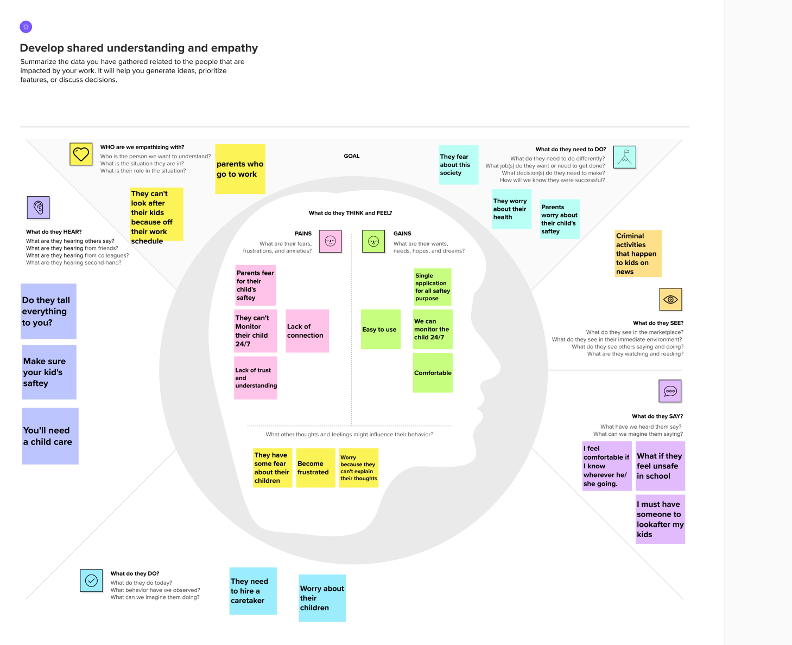

Reference:

https://app.mural.co/t/premkumar1589/m/premkumar1589/1665765339558/16853465544c64b7b0519af22776bcf1e9acc4d6?sender=udcb55bbd60239f8286189172